Instagram: nik_niknik_

Twitter: @ciuman_mati420

Email: [shopia.hazirah12@gmail.com](mailto:shopia.hazirah12@gmail.com)

Intro: mostly interested in character design ranging from humanoid to monster (deformed and simplified). I enjoyed collecting and creating dolls in my free time. My inspiration in the arts came from cartoons and Japanese special effects (tokusatsu).

Quote:

“NO PANTS NO LIFE” NIK 2025 HIDUP TETAP SEMANGAT

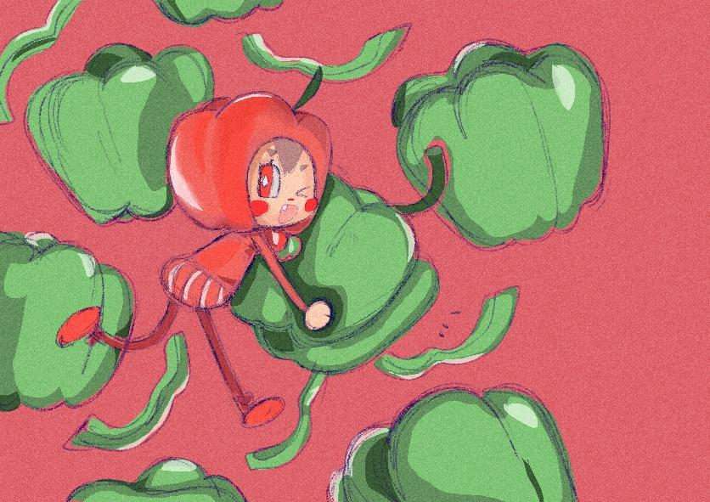

Bellpepper (landscape)(1)

My inspiration for my fyp animation

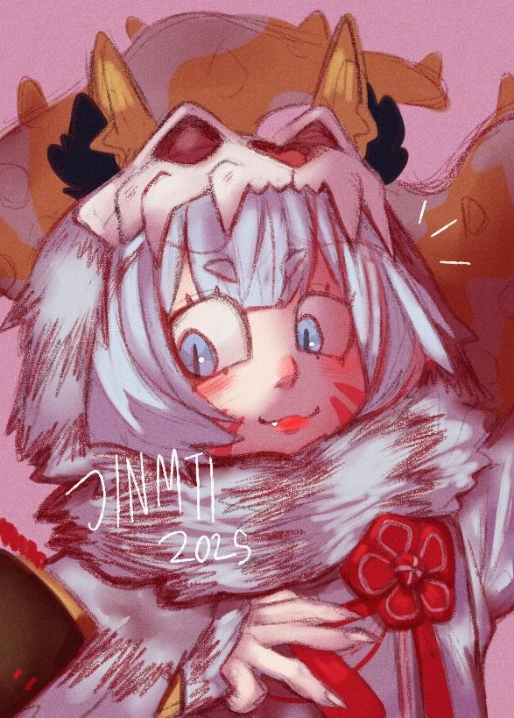

Baihu megido 72

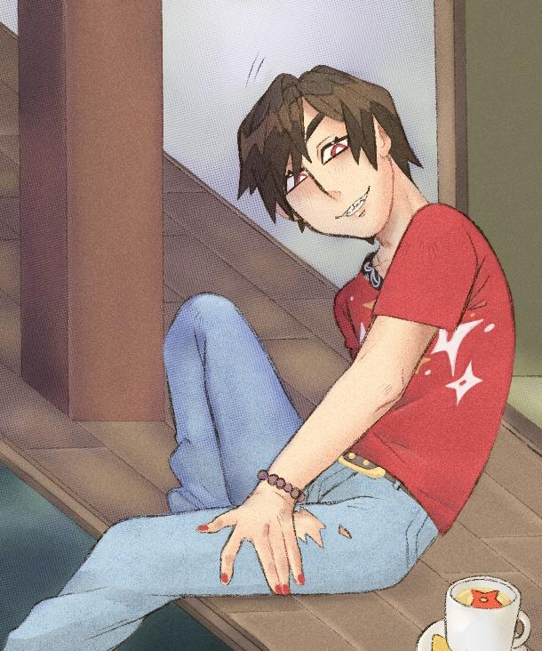

Igasaki takaharu nighttime tea

This guy is the red ranger in ninninger

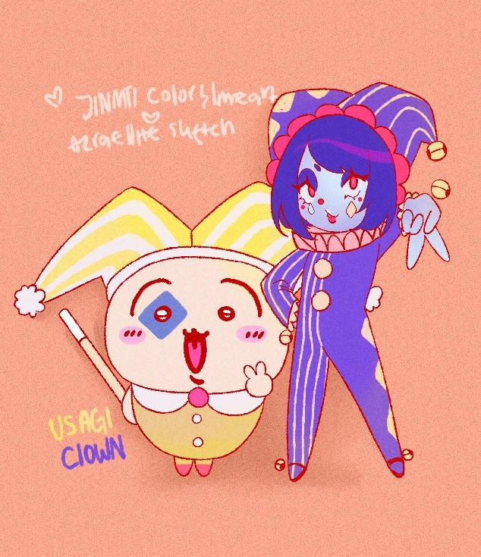

Usagi and my oc clown

Sketch and idea by azrin

Lineart and color by nik

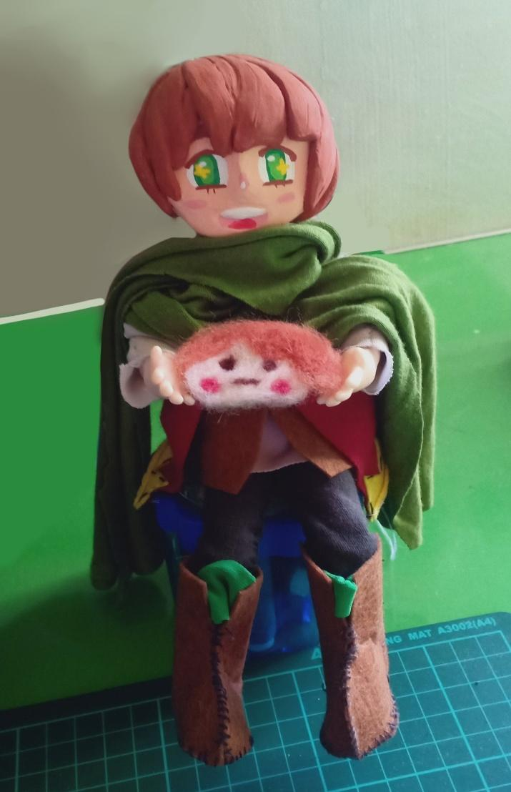

Claydoll of purson megido72

Made with paperclay, my old clothes and poster color.

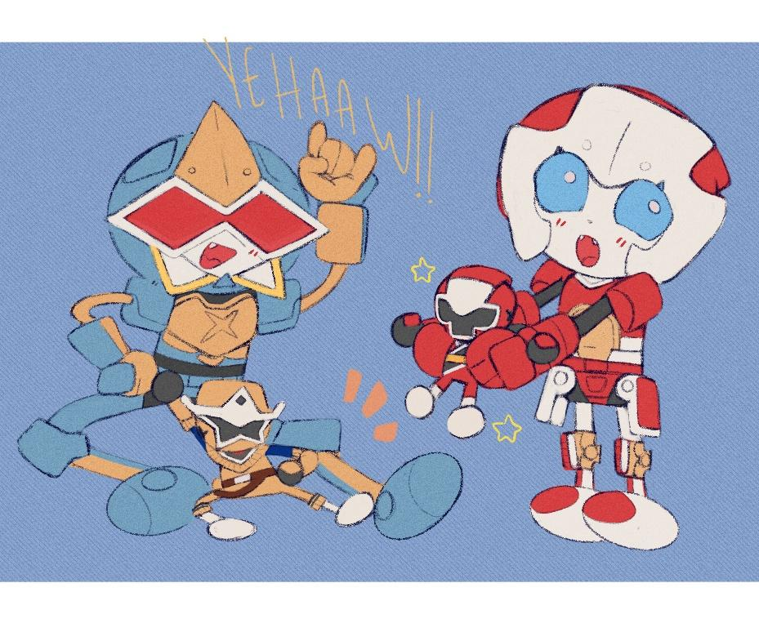

Yehaww

Characters from ninninger